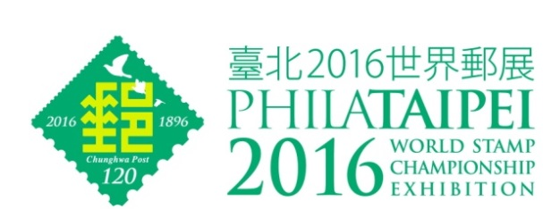
Philatelic Literature Exhibit Information Form

October 21-26, 2016
World Trade Center, Taipei, Taiwan

Author(s):

Exhibitor(s):
[if differs from Author(s)]

Title of exhibit :

Publisher / where to order:

Year of publishing (of current edition):  Which edition (1st, 2nd or 3rd etc) | ( edition)
Number of pages:

Format (..mm x ..mm): | mm x mm
Frequency of publication:  (periodicals only) | per year
Price:

ISBN:

Quantity Printed:

Brief description:
(up to 50 words)

Contents (to attach a copy of contents page, preferably in English, in addition to the published language)
Additional information: such as Preface, Introductory Page etc. would be useful

White—PHILATAIPEI 2016 WSC Exhibition Blue—Commissioner Yellow—Exhibitor

